Student: Alan Danque

Professor: Anthony Armstrong

Week 4 Exercise: 5.2 - 3 heat maps, 3 spatial charts and 3 contour charts using Tableau, Python and R

Git Repo Location:

<https://github.com/adanque/DSC640>

All Python, R and Tableau twb scripts and dataset & generated plots are located on this Repo:

<https://github.com/adanque/DSC640/tree/master/Week5>

**Heat maps**

Python

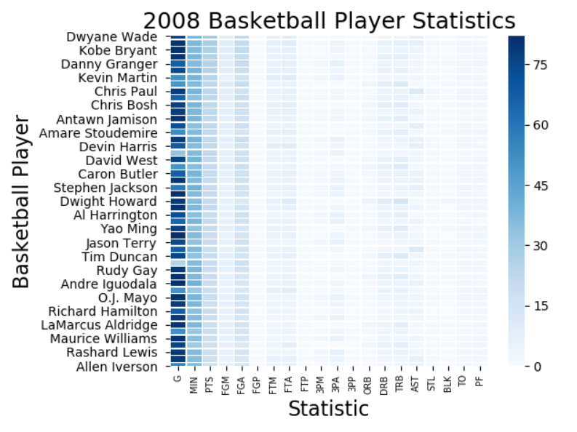

R

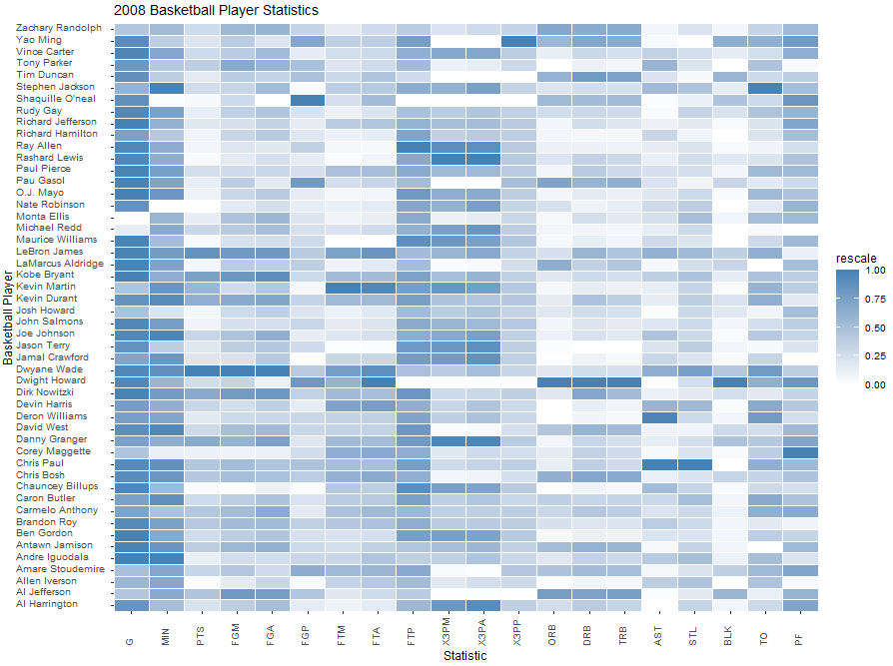

Tableau

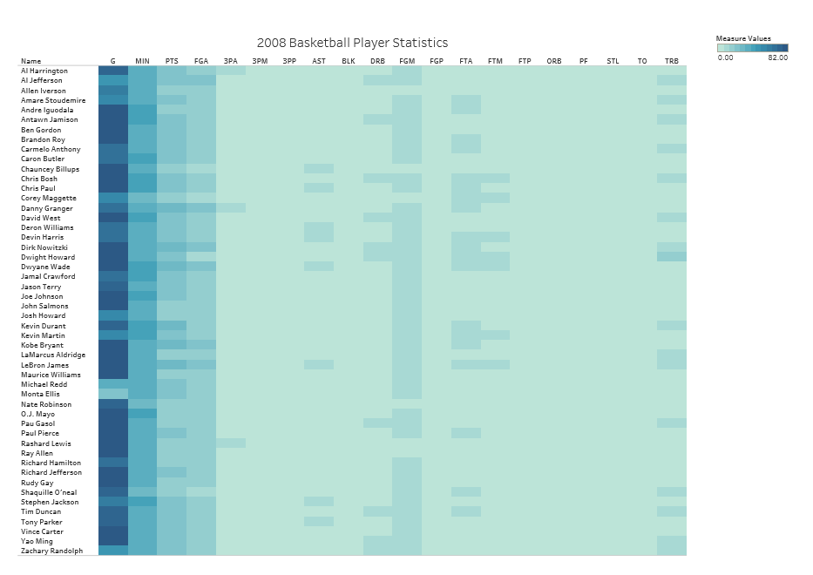

**Spatial charts**

Python

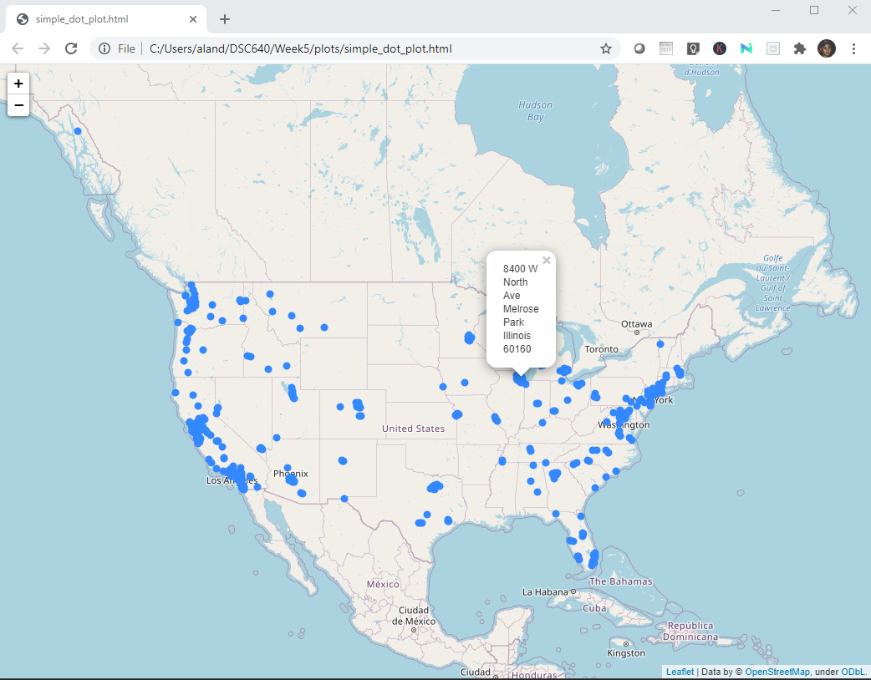

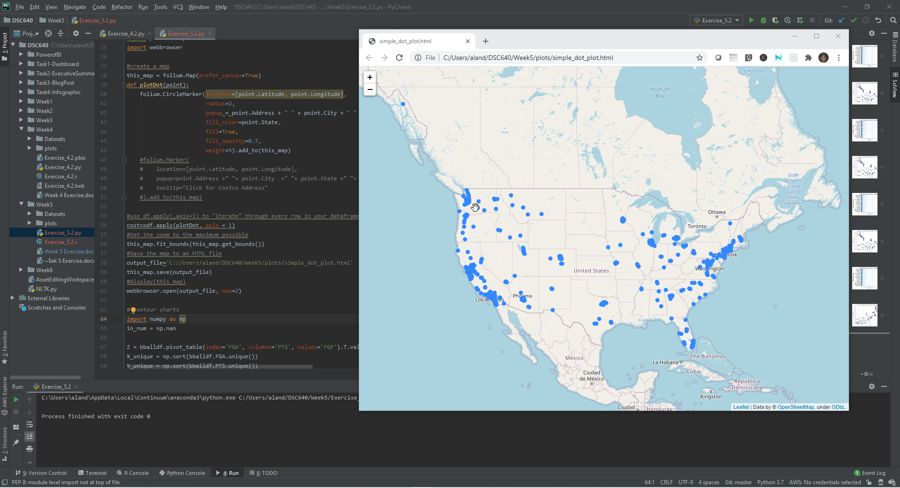

R

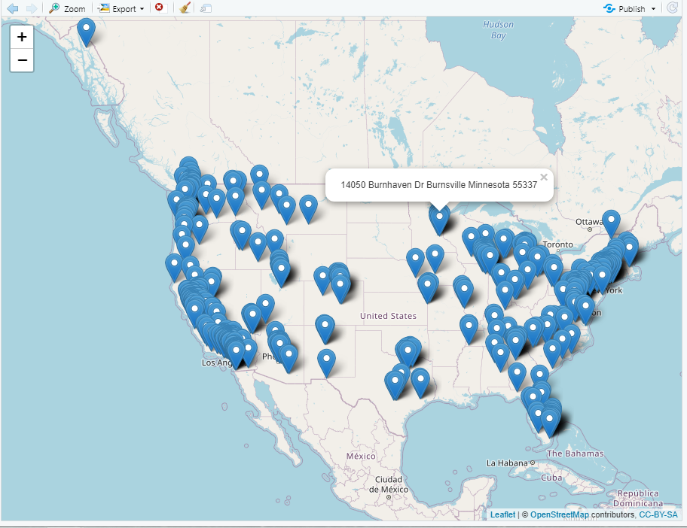

Tableau

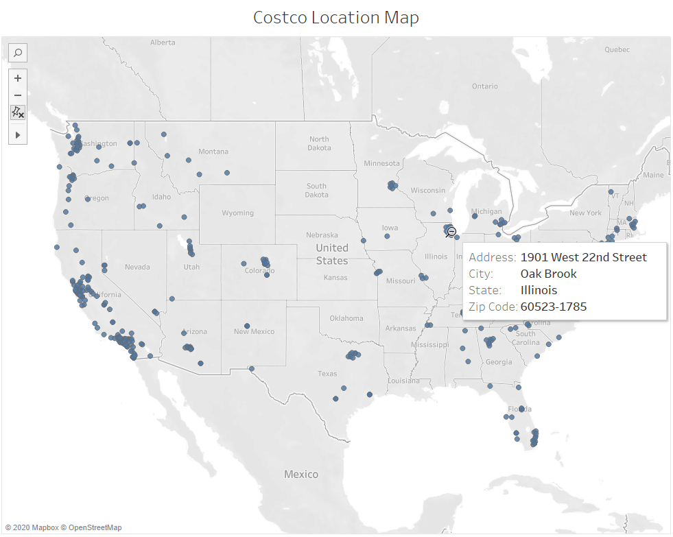

**Contour charts**

Python

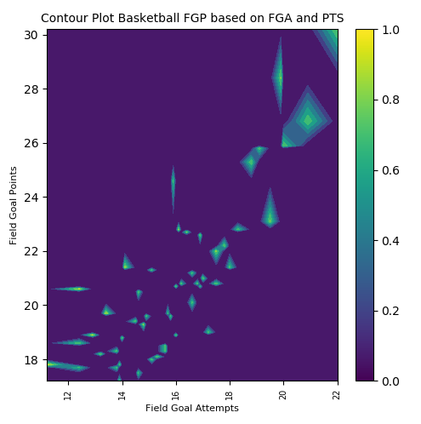

R

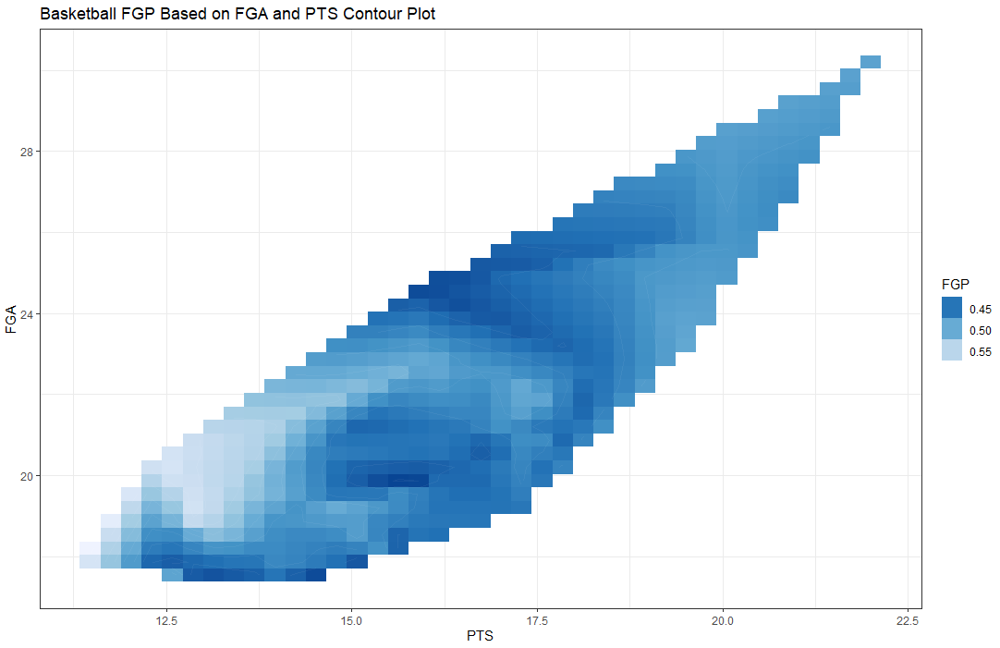

Tableau

